Jerry Olds  
1001533643  
IE-4378-001  
9/4/2019

Sensors / Sensor Fusion Needed for Competition

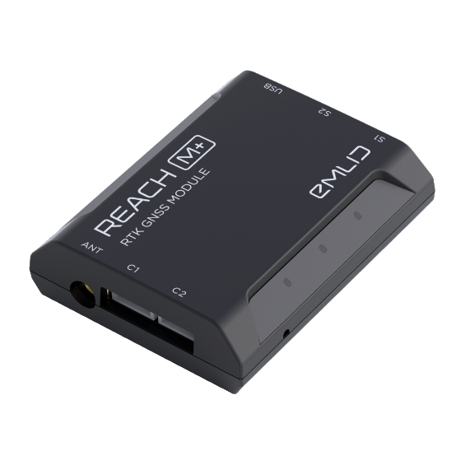

REACH M+ RTK GNSS Module for Positioning & Mapping

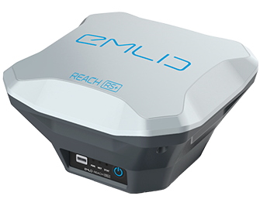

REACH RS+ RTK GNSS Receiver with/ App as Controller

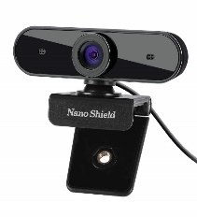

N910 Skype Web Camera Wide Angle

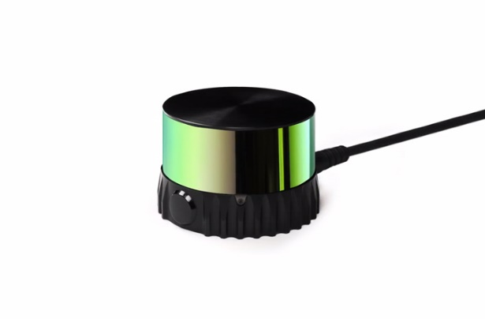

Ouster OS-1 Performance Lidar Sensor

Sensor Fusion

REACH M+ RTK GNSS Module and REACH RS+ RTK GNSS Receiver for position and orientation

N910 Skype Web Camera Wide Angle and Ouster OS-1 Performance Lidar Sensor for obstacle detection